------------------------------------------------------------------------------------------------------------------------------------------
------------------------------------------------------------------------------------------------------------------------------------------
TOUCHBACK ON THIS
Create your tribe and find sources of support.
Find places of inspiration and motivation. Find people to mentor you. Find sources of strength. Here are some things that may help you with this.
Here are some helpful Resources:
I encourage you to check out “Leading Others to Christ.” Dan Barker interviews some of the best evangelists around the Country. It is highly uplifting to watch these videos.
https://leadingotherstochrist.org
Benjamins Lee’s PDF Book, “It’s Not Rocket Science.” Ben has created a study book that has helped his church to grow the principles in this book are powerful and can help the beginning evangelist.
https://spiritbuilding.com
My site, (churchofchristevangelism.com) has training videos, books, and a training blog that includes some of the best advice from evangelists I’ve found. The Blog is called “blog insights” or “blog training.”
www.churchofchristevangelism.com
Someone who helped me as a “Mentor.” He may be of encouragement to you too.
When Ricky was doing a Gospel Meeting in Tampa, FL I saved the recordings. The lessons are chock-full of exceptional/uplifting content. I have the audio files here if you want to download them and listen to the evangelism lessons Ricky taught.
1 Lesson: Building confidence and boldness.
2 Lesson: Reasons for ineffectiveness.
3 Lesson: Edify the new convert.
4 Lesson: Prayer.
Ricky Shanks is the Preacher at the Gainesville Church of Christ in Gainesville, GA
Website link https://answersfromthebible.org
He did an evangelism interview video you may like to see.
https://leadingotherstochrist.org/interview-with-ricky-shanks
------------------------------------------------------------------------------------------------------------------------------------------
TOUCHBACK ON THIS
Find your motivation: fan your fear of Hell.
Find Sermons: Most churches and most preachers don’t give sermons regularly on Hell and Heaven. In part that is why evangelism is received with a lackluster attitude. If people are not reminded of these themes, graphicly and regularly, then why should soul-saving matter. In the great awakening during the 1800s, sermons were centered around the themes of Hell and Heaven. The sermons were about God’s judgment and the seriousness of being lost. Nowadays sermons are not regularly focused on these themes. I encourage you to find sermons online that talk about these issues. Find sermons on Heaven and Hell. Listen to them often.
Exercise to fuel your excitement for Heaven and your fear of Hell. If you imagine in detail at night before falling asleep in bed, the visual aspects of Heaven. If you think about the greatest moments of your life and allow yourself to feel those past experiences and sensations. And say Heaven will be even better. If you think about what the Bible says about Heaven, and you imagine in graphic detail being there. If you can picture your happiest moments in life and know Heaven will be even better. Your fanning your excitement for Heaven.
If you think about Hell and those who love going there. And if you visualize in your mind (in detail) about what the Bible says about Hell and imagine being there, you’ll fan your fear of this place. If you think about the worst memories in your life, the greatest hurts and reflect Hell will be even worse, you’ll find your sources of motivation...for sharing Jesus. If you read scriptures about Heaven and Hell… during your time before bed, and picture what you read in detail. If you imagine yourself being there and those you love… then Hell and Heaven will become more real and the need to save others will become more strong.
------------------------------------------------------------------------------------------------------------------------------------------
Videos of Hell for motivation:
Letter from Hell: https://fb.watch/bDJ4iU35RD/
Portrait of Hell: www.youtube.com/watch?v=Rl1lzmx_UKs This is not my video, I uploaded it for personal use. You may find it intense.
Video about conviction:
The Apostles believed in Heaven and the gospel message so much as to be willing to die to share it. Would we do that for Jesus and for His evangelism work?: https://fb.watch/bDJ9Fq-H6p/
------------------------------------------------------------------------------------------------------------------------------------------

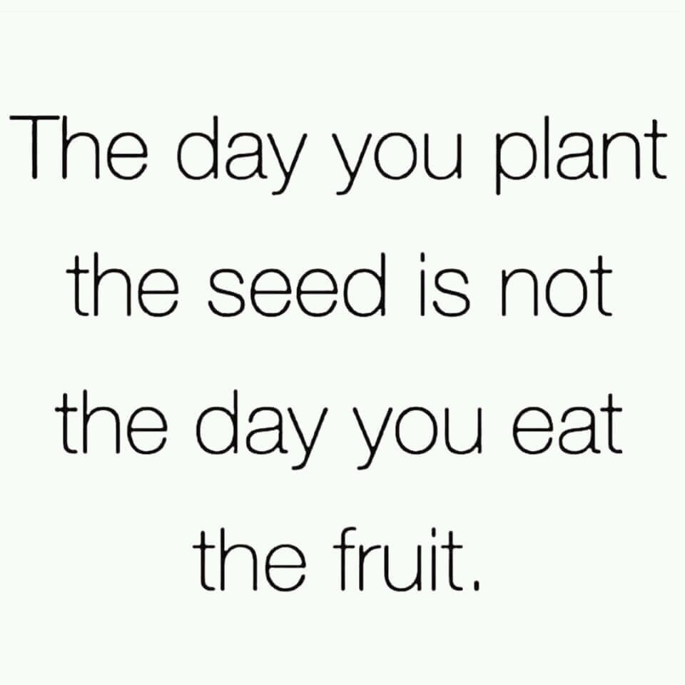

Remember to just start. Wherever you are at. The beginning is what matters. The rest will follow over time. Do what you know and start from there. With time you will grow and evolve. Remember it’s not about instant results. It’s about honoring God by doing the work He wants of us. The results will come with time. Even if you never see a certain result from a certain action, it does not mean no good came about. I have heard of stories of people visiting churches, asking for studies, because of a seed someone else planted. You never know the incredible good you can do with just one action.
------------------------------------------------------------------------------------------------------------------------------------------
Ideas on evangelism:
How to view the New Convert and the lost souls.
People are beautiful, not in the way of lust, desire, or attraction. But males and females, boys, and girls, young and old, are beautiful, for this simple reason...God loves them, (Romans 5:8). And if He loved them enough to give His Son. They are pretty precious. And what is tenderly treasured by the Father and deeply valued should also be cherished by His children.​
When it comes to salvation, remember it's the truth that brings the lost to Jesus, and it's the truth that holds the new infant, in fellowship with the Father. Yet love is foundational in joining them to a spiritual family of believers. The Apostles, John (3 John 4) and Paul (1 Timothy 1:2) call new converts their children. Obviously, we are all sons and daughters of God, but in this inspired text, we see that... those who were taught and those who did the teaching (can and should) have a bond that feels paternal.
Do parents give up on their children or undermine them? Do fathers or mothers look out for their own interests first or their sons and daughters? Spiritually speaking we need to look out for the spiritual welfare of new infants and do what parents do for their children. We need to mentor them, (spiritually speaking).
We need to help them grow up in the Word, the milk of the Lord, as newborn babies, (1 Peter 2:2). And not let them stay stagnate in a weakened state of infancy through a lack of training and teaching, (Hebrews 5:11-14). The relationship is paternal. Paul called Titus, (Titus 1:4), and Timothy (1 Timothy 1:2) his sons. He worked with them and taught these young men.
So, we should look at new members of the faith as people we can help raise up from infancy to spiritual adulthood. As you help them grow, remember evangelism does not stop at the baptism experience, that is where it begins. Before and after the conversion process, evangelism requires mentorship. It requires an investment of time and energy. As a father teaches a child how to act through inclusion, examinership, and verbal guidance, we too should nurture God's spiritual children, (1 Thessalonians 2:7-8).
We were born to reproduce. To share the spiritual seed, the Word of God, (1 Peter 1:23;25). To make more sons and daughters of the Father. This is in our spiritual DNA. This is our truest calling as children of God. We are here to make more people, through the truth, in the image of our heavenly Father. For that is why we were saved, “why we have been brought out of darkness into His wonderful light, to proclaim the glories of God,” (1 Peter 2:9).
That is our meaning and spiritual life purpose. We cannot find true fulfillment in Jesus till we do what we were put on earth to do. That of following this highest act of love, to save another, (Jude 23). That of meeting the greatest need the world has...that of making the lost into God's children. Our spiritual biology and our role as the saved is to save. We are here to reproduce through sharing the seed, the Word of truth. We are here to share our Father’s message. We are here to bring about rebirth, through the "water and spirit,"(John 3:5).
A man and a woman find completeness in creating a physical family. In spiritual matters, we can only find completeness in creating a spiritual family. Both are centered around love, and both fill us up with purpose. Both require stewardship, work, time, and give emotional satisfaction. Both roles are God-ordained. And are mutually symbiotic in the emotional bonding that comes from being a mentor.
------------------------------------------------------------------------------------------------------------------------------------------
The right perspective: Evangelism is a lifestyle. It is a process that gives results with time.
Take steps and allow yourself to grow.
A process is about investing in an ideal, to get the desired result. No one asks one girl or guy out, on a date, and if receiving a "no," gives up... saying "dating does not work."
No one goes to college and expects a diploma the following day or week. No one goes to the gym once a year and expects to have the desired results before them in the mirror. Or diets and weights the next day expecting the weight loss goals to have been achieved. In all secular dreams and goals, we understand it takes time, work, and an investment of one’s life, for the results to come.
Yet in spiritual themes, many think a single action should bring about an instantaneous development in one’s life. A single prayer, Bible study, evangelism action, is not an investment in a spiritual process. Yet people expect instantaneous results and growth from the minimal time they have given to one single effort.
People say, "I went door-knocking for an hour" or "did campus work for an hour" on the eve of a Gospel Meeting and "no souls were saved." "No one came to the Gospel Meeting." Sometimes lighting hits, but usually, for results to come, a person has to invest in the process.
Love the process and the results will come. But be aware that God wants your lifestyle, not a token deed done. Invest in Elohim and the Tribune will invest in you. No wall is built by a single stone and no dream is built by a single act.
All architects build by one brick at a time, by one beam, one nail, one piece of wood, they build. They see the design and the end result. They engage in the process and invest in the vision they see. Let us do this for our spiritual monuments we wish to design within ourselves and with the world.

------------------------------------------------------------------------------------------------------------------------------------------

How does Jesus view our Fathers will? John 4:34-38
What do we need to do to have that same will?
How to fuel your passion and fire for evangelism.

1 Cor 5:9 So we make it our goal to please him, whether we are at home in the body or away from it.

14 For Christ’s love compels us, because we are convinced that one died for all, and therefore all died. 15 And he died for all, that those who live should no longer live for themselves but for him who died for them and was raised again.

Visualize the good that can be done. The example and role model you will be for your family. The closeness you will have in fellowship with God, when you follow this greatest commandment of love and compassion. If God is love and you share Jesus in the Name of Love, think how powerful…. will be your bonds as you grow closer with the Father and the Son.

Read scriptures. Faith in heaven, hell, appreciation of what the “Lamb of God” did, increases through the reading of the scripture. Roman 10:10.

More ways of fueling ones passion/fire

Think about yourself/loved ones… Philippians 4:8

One does not have to wait for Sunday to think about Jesus' death on the cross. Light a candle, sit in the dark, think in vivid colors the details of your Saviors suffering. You can read scripture in context to this or just think on this ideal. Tell yourself while you’re doing this, "He did this out of love for me." If you feel unloved, unlovable, alone, you'll know this truth. You'll know that someone loved you, enough to value your life, to suffer and die for it. You are loved and your never alone.

On Sunday’s or when doing this alone in my room, I think of those who I love, that are saved, my mother, father, etc. And myself. I know Jesus took my place. And those who were lost. But for a little time, I think about those I love being flogged, being beaten, hit in the face, mocked, and then crucified. I think about myself going through this as well.

Then I think about Jesus take those I love/my place and taking these pains upon Himself. For that is what He did. We should have died for our sins and been punished for our crimes against God. Yet His Son took our place. This visual mediation helps me appreciate the sacrifice of Jesus more and value this gift more highly.

Lessons from Nehemiah
Until kingdom culture changes in certain matters, congregations will continue to die out. Let’s look back into the past, further then 50-70 years ago. History always has lessons for us to learn. Around 520 BC Haggai was instructed by God to talk to the people of Israel. What did God want Haggai to communicate?
This is what the Lord Almighty says: “These people say, ‘The time has not yet come to rebuild the Lord’s house.” Then the word of the Lord came through the prophet Haggai. “Is it a time for you yourselves to be living in your paneled houses, while this house remains a ruin?” Haggai 1.2-4.
Read Deuteronomy 8:1-19
In Christ’s kingdom, what is the focus of most members? Many are interested in their houses, kids, cars, and football teams. And there is nothing wrong with that. Yet too few pay attention to the needs of their congregation. It is because of this neglect; churches are dying out across our land. What are we placing first in importance as our first love? Is it God?
Will God say of us, I hold this against you: You have forsaken your first love, Revelation 2.4. What we love most is what we prioritize first, For where your treasure is, there your heart will be also, Matthew 6:21.
During this time Nehemiah, (while in Babylon) heard about the state of the Jewish Kingdom. What did he do?
And they told me, “The remnant who survived the exile are there in the province, in great trouble and disgrace. The wall of Jerusalem is broken down, and its gates are burned with fire.” When I heard these words, I sat down and wept. I mourned for days, fasting, and praying before the God of heaven, Nehemiah 1.3.
To change the kingdom, we must be aware of its state of troubled and disgrace. And yes, when God’s kingdom is losing more people than it is bringing in from the world that is a sign of troubled time. Such a situation of neglect is also disgraceful. Nehemiah heard the news and did what? Did he say, “O well” and ignore the serious issues of the kingdom? No, Nehemiah, was a person of conscience. He felt the tragedy of this news and he mourned. This man cared and shared his concerns with God in prayer, with tears and fasting.
People need to be aware of the state of the Lord’s kingdom. The walls are broken down, and its gates are burned with fire. Like Nehemiah, we must know what has happened and we must care. We must ask for God’s guidance. Nehemiah prayed for success in kingdom work, Nehemiah 1:11; 6:9. We must do the same.
But prayer and faith alone are not enough. Remember, faith without works is dead, James 2:20. What did Nehemiah do? He prayed and then traveled to Jerusalem from Babylon inspect the walls secretly by night. He did this to put together a plan, Nehemiah 2:11-16.
Once Nehemiah counted the cost and planned, then he went out and got to work. As he did, he got others involved, Nehemiah chapter 3. Nehemiah and those doing the work were opposed, criticized, threatened, and demeaned by people in and out of the kingdom, Nehemiah 2:19; 4:10. Yet they kept on working. If you do God’s work of rebuilding the spiritual kingdom, you will be opposed too. Yet, in this effort of kingdom work, you must not give up.
During this time, both Ezra and Nehemiah led the people of God. Ezra rebuilt the temple; Nehemiah rebuilt the walls. God through Ezra helped The people gathered together as one man to Jerusalem, Ezra 3:1. God through Nehemiah… got the people working. So built we the wall; and all the wall was joined together unto the half thereof: for the people had a mind to work." Nehemiah 4:6. We need such men and women in the church today, to build up the spiritual kingdom, one brick at a time. We need leaders to encourage others to get to work.

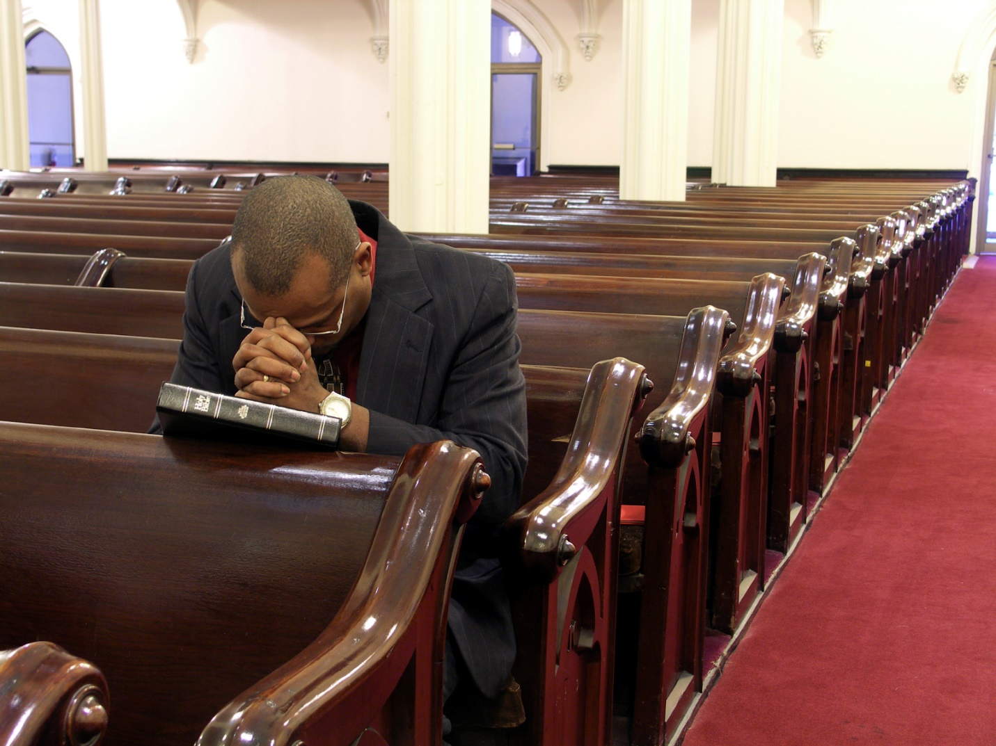

Formats for church growth
Make evangelism a part of the church’s culture.
- Have a special interactive evangelism lesson/workshop given during a church service, in place of the regular sermon at least once a month. The themes that can be talked about,
is the church’s decline in the kingdom, the need to save the lost from Hell, the spiritual biological duty we have to reproduce, the Bible commands us to share Jesus to be pleasing to our Father, specific methods of doing outreach, NT stories of Jesus and the Apostles doing evangelism, sharing success stories of those who came to Christ, ideas to grow a church and make a church more welcoming to visitors.

Have the leaders announce evangelism themes, encourage church members to pray and speak in short talks, etc., about s
ideals during worship. Culture is best influenced when the leaders participate in evangelism work. If the elders and preachers are not interested, it can hurt the development of evangelism culture. The outreach can still be done, it makes the growth of the culture harder.

To implement evangelism culture, you need to do evangelism. I have seen “evangelists” talk about outreach work and not do it. Year after year, the church becomes less evangelistic. Hypocrisy, especially in leaders, preachers, AND EVANGELISTS, stifles the zeal of such work. No one follows the advice of an apathetic speaker.

Mentorship: Be leaders. Make leaders not followers.

- Find people to mentor and train as leaders in evangelism work. Evangelism is mentorship.
To those who coach a little league sport, or run a company, to parents who spend time raising children, or to women who head up a girl scout meeting, you have been in the role of the “mentor.” This term (mentor) holds great weight in its capabilities of molding lives and in instilling positive habits. Did you know the origin of mentorship is Biblical in principle?

God speaks of the virtues of mentorship in Proverbs 27:17 when the passage states, as “Iron sharpens iron, so one man sharpens another.”

We think of a karate teacher being a mentor or an influential and caring high school teacher as a mentor. Many of us can look back at individuals in our lives who have helped us to become the people we are today. The word “mentor,” as we think of today was given a different name 2,000 years ago. The work of mentorship is the same NT ideal we can read in the Bible for discipleship.

Discipleship in NT Greek is mathētḗs (μαθητής). This term means “one who engages in learning through instruction from another.” Other terms for disciple are “pupil” and “learner.” https://biblehub.com/greek/3101.htm

A cooking class can “disciple” you into a better cook. A personal fitness coach can “disciple” you in diet and the best workout routines and exercises. When we look at the storyline of Jesus, we read of a spiritual application to this term called “discipleship.”

To mentor or disciple, a person is to mold someone into a certain way of being. No one goes to one workshop and has all the answers in any given field nor does one immediately change into a better version of themselves in any area they are pursuing for self-development. Discipleship in any area is a process. FOR MORE ON Mentoring new converts, you can download my Discipling book here.

A leader needs to make leaders, not followers.

Get the students to commit to help with a study or evangelism event, the more they commit to the more likely they will commit to further things. If you can get one student to say yes to helping with a study, that student is more likely to say yes, the next time. If you can get a student to help with a campus evangelism event, that student is more likely to say yes the next time.
​
The goal of evangelism is mentorship. The goal of leaders is not to create followers, but leaders. Yes, short term new members in a group will be codependent. But as a leader works with the group, as they become comfortable and evolve, the leader needs to encourage them to take roles of leadership. He should show them how to set up events, teach classes, by having them accompany him to such activities, then slowly getting them more involved in the process of event creation and class teaching.

The Bible’s words for disciple means to mentor, that is to disciple people into the pattern of Jesus. What did our Lord do while on the earth? He told people to “Come, follow me,’ Jesus said, ‘and I will send you out to fish for people.’ At once they left their nets and followed him.” - Matthew 4:19-20

During ministry, Jesus trained His Apostles, and disciples, (Matthew 5:1-2) in the work and teachings. Christ showed the disciples His example and included them in His life.
When our Lord taught the crowds, (Matthew 23:1-4).
When He prayed, (Luke 11:1).
When Jesus did evangelism work, (Matthew 4:18-23).

Jesus later send Apostles out 2 by 2 with the 72 disciples, (Luke 10:1-16), to do evangelism.
When they got back the Lord Jesus worked with them some more, after this outreach work, (as the gospels show in its timeline).

Once the disciples had been shown the truth and had accompanied Jesus (seeing His example) when He did outreach and other spiritual activities, Jesus encouraged them to go out and try these things themselves, (Matthew 10:1-42; Luke 10:1-24). Our Lord even asks Peter to do step up and do spiritual things after the resurrection, (John 21:15-19).

Discipleship is about fostering a sense of accountability in doing Christian work. It is about encouraging new Christians to step up and do more for the Lord, as they grow and mature in the Word.

When they were ready, He said to them, (upon His departure to heaven) in the Great Commission to go out and make disciples, (Mark 16:15/Matthew 28:19-20). He wanted these followers to follow His example, of being a servant, (John 13:15). As disciples of Christ, we are supposed to do this as well.

Discipleship is about fostering a sense of accountability in doing Christian work. It is about encouraging new Christians to step up and do more for the Lord, as they grow and mature in the Word.

If the only leader in evangelism is the paid preacher or paid evangelist, what happens if one of them gets sick, falls away, is out of town, has a family emergency, moves to another congregation etc. Well, that church is back to square one. The more leaders a church creates, the better is its future. The more selfless men/leaders out there are who have this mode of thinking the better. When such men are willing to place others in the position of authority as leaders in mentorship, they are helping the security of a congregation.

Also, the more evangelism teachers, event creators there are... the stronger and long lasting the evangelism culture will be. Let me share this as a quote: The best leaders are not focused on creating followers, but leaders. Followers-only, follow as long as they have a person to guide them. When we create independent, self-reliant, responsible leaders, we do more than “give a man a fish for a day, we teach a man how to fish, and thus feed him for a lifetime.” Yes, we all begin as followers, we are dependent, we must look to another for guidance...for a time, while we are getting our footing. But a good leader, encourages others to develop to the point where they too, can lead.

Jesus looked for opportunities in matters of evangelism. A key phrase I think of when I work with new Christians or possible future saints is this, “discipleship is mentorship.” It reminds me of the (spiritual) role I must play in the lives of those I interact with. As a mentor I must instruct others and give an example for emulation and guidance, (in matters of the truth).

------------------------------------------------------------------------------------------------------------------------------------------
Preparing a Church for new converts and visitors.
Making a church a supportive church.
- Preach or give a Bible lesson at least once a month on the importance of being a welcoming, hospitable, loving warm church.

- Have assigned greeters at the entrances. And 5 assigned greeters within the congregation to greet people new converts/visitors, sit with them during worship, get visitor cards from them and invite them out to eat. Hospitality is highly effective in cementing bonds and in impacting people in how they view the church. Is it loving or loveless? Is it cold?

Or do the congregations have cliques? The more inclusive a church is in interacting with the new converts and visitors the better the retention rate of the new converts and the follow-up visits from the visitors. These activities do not need to be only practiced by those assigned. It is best if this activity is intertwined with the church’s culture. That people will be hospitable because it is regularly taught, it is expected, and it is regularly practiced by the leaders. Leaders are influencers and can impact the culture for good or ill.

- Have the church members do the “5-minute rule.” Many successful churches do this. Have the church members greet/talk to visitors, the new converts, the discouraged, for 5 minutes, (at least) before talking with their friends.

- Incorporate new converts into church work or spiritual work without the church immediately after conversion. This increases the retention rate. People who feel like they belong are those who are included in the kingdom, not excluded. Train new converts into leadership roles. The more you invest in them, the more they will invest in the congregation.

- A church needs goals and a purpose. A church without meaning will create drama and issues. A church that has its members too busy doing God’s work, too busy encouraging, loving others, helping people, being positive will not have time for the ideal distractions of sin, in any of its forms, gossip, divisive talk, power games, etc. The behaviors of Christ in doing the duties of church service to encourage, etc. will better foster within themselves these ideals of love, compassion, empathy, positive interest in others. The more people’s energies can be channeled to positive things the less likely they will have Satan distract them with the negative use of energies. Idleness, directionlessness, etc. are the devil’s playhouse. Too much nitpicking and petty behavior become a purpose for saints, who want to have a meaning. Power games are created when the vacuum of a purposeless church. A purpose drive church creates selfless workers. A directionless church creates anarchy over the long run. Have a plan for doing outreach. Have measurable goals for the church members to aim at.

------------------------------------------------------------------------------------------------------------------------------------------
Keeping the New Converts/visitors and new members.

- Train/ground new converts in weekly Bible studies for at least 2 years. If possible try to do this in people’s homes. This increases the retention rate. I had an 80 percent success rate through doing this process. Focus on classes that will train people to teach new convert material and in sharing sermons/Bible lessons centered on hospitality. Specifically, in what is mentioned here, certain themes should deal with encouraging people to be hospitable to new converts.

- For new members have the elders invite them out, (one at a time) to get to know the leadership. Also, have the preacher/evangelist do this as well. Have 6 families be assigned to invite the new member out to eat or to a home-cooked meal. This will help get the new members to get to know the congregation and to better get them bonded with the members/and the members with them. It is best if this activity is intertwined with the church’s culture. That people will be hospitable because it is regularly taught, it is expected, and it is regularly practiced by the leaders. Leaders are influencers and can impact the culture for good or ill.

- Get the new members signed up for church duties. Every member needs to do something. It can be as small as emptying the trash cans in the bathrooms. But members who invest in a congregation will feel like they are a part of the group and feel invested in.

- Train new members and new converts in evangelism work and in doing church work. As well as the themes of being welcoming to visitors and being hospitable.

- Have a group or groups, depending on how big a church is, that meets at least once a month, where people can gather in one another’s homes to eat and to talk about church goals, plans, and assign activities, (visiting the sick, the elderly, the discouraged, etc.) and focus on doing spiritual things, like a Bible devotional, singing writing cards to the sick.

- Have a potluck for the whole church in a park, or home for the members just to spend time together. This helps build bonds. And helps the new members circulate and get to know the rest of the church. Do this at least once a month.

- Have a grapevine where news is sent to the members. It can be in texts or emails. Such news as outreach events, baptisms, people who need to be encouraged, upcoming Bible studies, congregational duty needs for work, sad news of deaths, spiritual opportunities to help someone, etc.

- The church can have small groups centered on specific things, like follow-up with visitors, writing cards. Texting, writing people who have missed a lot of services to check on them. Check up on people who are discouraged, etc.

------------------------------------------------------------------------------------------------------------------------------------------
My favorite evangelism methods:
- An outline of Working with the Young People:
Invest in your church young people.
- Get them active in Bible class
- Give them church projects to do
- Mentor them into leaders
- Give them roles of service to do. Teach them how to save others, how to do song leading, etc.
- Have them help you with spiritual activities.
Example: Bill Sanchez
- Bill was saved through mentorship in his youth. Bill works with the youth at church through mentorship. Bill Sanchez teaches teenagers in Bible classes and has the boy students each prepare a lesson to teach. The teens invite their friends to hear them teach the Bible. This has a multi sided blessing, it firstly trains young men to be teachers, it helps to ground them further in the Word, it gets them more invested into Christ and His service, and it turns these young men into evangelists. Through this method, their friends have heard about Jesus. Such involvement with teens from the community is powerful. Bill focuses on teens in his outreach in other venues as well.
Resources:
Bill Sanchez is the Preacher at the church at the Embry Hills church of Christ.
Website link http://embryhills.com
To see his video on evangelism work, click on the below link.
https://www.youtube.com/watch?v=iOL2mGJ0BJs
------------------------------------------------------------------------------------------------------------------------------------------
- Church invites or Bible study invites:
Invite visitors to Bible studies. Have measurable goals. Have church members try to invite 10 people each month. Pray about this activity when together as a gathered outreach group. And as a congregation. Inviting friends and strangers to Bible studies when doing day-to-day activities. Can add cold approach. This can be combined with “Coffee shop” evangelism.
Example: JP Flores:
- What he does for success...in my personal interactions. His evangelism workshop lessons can be accessed at the sermon/media page on the University church of Christ website.

Stage One: This man gets about a baptism a month or every other month. His strategy. The church teaches in the assembly an evangelism workshop at least once a month, on a Sunday, in place of a Bible sermon. The workshop shares the Christians responsibility to reach the lost, God’s teaching on evangelism, the methods a person can do in sharing Jesus. JP focuses on individual accountability to invite people to church and to Bible studies. The goal is to foster a climate of evangelism. And to make this a intertwined piece of the churches culture.

Stage Two: JP sets up multi Bible study groups in places like Starbucks, Panera Bread, even people’s homes, that get together each week. He has leaders in charge of these studies and he, himself helps with the group work. Christians at church are encouraged to invite coworkers, neighbors, etc. to the studies. The studies, act as door openers for creating relationships, and to stir up emotional investment in the members there. The studies are door openers for getting the non-Christian students to commit to a more personal study on salvation related themes, once they get involved in the group and the original study, (through attending/investing interest).

Stage Three: Follow up. New converts are further studied with and included in spiritual activities. The elders/preachers coordinate with church members on the visitors, to encourage letters, cards, after they visit and to encourage meeting them when they do come to church, when people invite them to the assembly.

Generating further contacts. JP runs an ad on Facebook that gets Bible studies each month. He learned this method from Don Bunting. JP gears the ad to his local area where the church is at. The ad is focused on getting Bible studies. See link. https://tampachristians.com
Resources: Paid evangelist at the University church of Christ.
Website: www.universitychurchofchrist.org
His training videos are at www.universitychurchofchrist.org/media2?title=evangelism&y=0&se=0&sv=0&sp=0
------------------------------------------------------------------------------------------------------------------------------------------

- Many evangelists do “Coffee shop evangelism.“ This is done by doing Bible studies in public places. It can be at coffee shops, fast food, or dine-in restaurants. Here is an uplifting evangelism video from a young man named BJ Sipe on “Coffee shop evangelism.” www.facebook.com/leadingotherstochrist/posts/475723354145848
Example: Andy Cantrell
- Andy since he was in his teens, saw church members greet visitors with these slogan phrases like, “Hey nice to have you, glad you are here.” “thanks for coming to visit us.” Yet Andy noticed visitors from the community were not asked (in a warm/tactful/personal way) certain (conversation oriented) questions like, “How are you doing?” Andy says such a question conveys interest and should be followed up (after a contact gives feedback and a response) with further social interaction. A person should (tactfully, and warmly) give questions centered around asking them, “why are you here?” Then, “what are you looking for?” then, “what’s your story?” then, “would you like to study the Bible?”
This format is ingenious. These questions are deeply connective and rapport building. They say, “I care about you,” and “I want to know more about you,” (in regard to spiritual things). Then in giving an invite to personally meet to study in connection to the personal (social) groundwork and foundation being done, it makes the invite more effective. Andy even in his teens, got Bible studies doing this approach.
When looking for a Bible lesson format as a teen, Andy Cantrell mentions doing Ivan Stewart’s “Open Bible series.” And saved souls through using this material. Andy now does evangelism workshops at the church he attends. He says training others in evangelism is important.
Luke Heard (is a young married man in his 20’s). Luke has learned “Coffee shop evangelism” from Andy Cantrell. Luke goes to the University church of Christ, where I attend. He let me interview him and pick his brain on this method, (that was taught to him by Brother Andy).
Andy showed Luke how to do Coffee shop evangelism. The clip details this but I want to write this down as well. Andy has had success with doing this method. Luke said his Brother in Law, (who is also a preacher) has had success as well with using this outreach format.
The specific method Andy uses:
- Andy goes to the same coffee shop at the same time, 2-3 times a week.
- He sits down at a table, gets out his Bible and opens it up.
- Andy sits and (casually) looks at people coming in.
- If they make eye contact with him, he’ll smile. And wave to them. If they wave back, Andy will try to say something to them. Like ”hi” “good morning,” etc.
- Usually, they are dismissive. But if they look at him, Andy thinks…”Alright I’m going to try to get this person to sit down.”
- The person can see Andy has a Bible and its open, so the individual knows Andy is studying the Bible.
- If Andy gets interaction he will invite that person to sit down and offer to buy them coffee.
- When it comes to money, Andy has a “kingdom fund” where he sets money aside every single month. Just for that specific service.
- Andy has also developed connections with the staff and those who work at the coffee shop.
Andy says the key in doing evangelism is in genuinely caring about people, about their souls, their lives, what they’re going through, about who they are as uniquely created men and women of the Creator. Saving a soul is not about trying to get a notch to put on the belt. It’s not about trying to get people to “join our church.” It’s about helping people find Jesus. Evangelism is about letting people know you care. Having empathy towards others is a powerful tool in connecting with people and in getting them to emotionally invest in you and in what you’re sharing.
Resources: Andy Cantrell is the Preacher at the Northwest church of Christ, New Hope, MN
Website link www.nwcocmn.org
His interview video from “Leading others to Christ” is at
https://leadingotherstochrist.org/interview-with-andy-cantrell
Please know you can just sit and have Bible studies. That is what BJ Sipe does and many others. This is just the way Andy does this form of work.
------------------------------------------------------------------------------------------------------------------------------------------
- Cyber evangelism is highly effective. People use social media to reach the lost. Instagram, Facebook, Google search engines, etc. have been great tools for sharing Jesus and for getting Bible studies.
Example: Don Bunting.
- Don uses internet ads like “Google ads” to “invite people to have a Bible study.” He has a website where people go to when they click on the ad. This site is where he highlights this focus of evangelism. It details constructive ways of getting people to sign up at the site for Bible studies. See site here https://nycbibleteacher.com/don-bunting.

This site can serve as a good template for replication. Don has brought many to the Lord through this method of work in serving Christ with the gospel. Number 1 question people ask when contacting Don Bunting through his ad is this… “does your church have Bible class,” or “what type of Bible classes, (inside/outside of church) do you have?” Let me stress I know of other preachers, who have had success with this method. It is extremely powerful.

It’s good to have out of church class groups set up and excellent congregational (for all ages) Bible classes set up for the times of meeting. It’ also good to know the topics and themes of both of these class formats. Know the positive points to share when people text/email or call to ask these questions.
I keep hearing about evangelists using Meetup.com and Zoom (to invite others to online or offline) virtual Bible studies. Don Bunting is one such person doing this. These are effective methods.

Don always says a friendly and loving church makes a difference. Visitors need to be made to feel welcome. Also, having the right attitude in the church makes a big difference. A congregation should be upbeat, happy, warm, social, caring. A cold, apathetic, sad, gloomy church hurts evangelism work. When visitors come in and see the good attitudes, this impacts them positively, if they see the bad attitudes saturate a congregation, they won’t be coming back.

Don is doing what other cyber evangelists have done, that are also getting the same success. That being, they are running ads that invite people to a Bible study or they are doing Bible courses to lead to the same result. Two people I’ll mention worth checking out are JP Flores and Clint De France. They use Facebook ads to generate studies. JP gets about a dozen studies a week, Clint around twenty studies a week. . I studied up on Clint awhile back. I put the data I learned at this link here. I also copied the website into a file, here.
Resources: You can also watch the interview video from the University church. This video is very in-depth and has more details on outreach. Class video www.youtube.com/watch?v=QcUq2W_FvUs
Don Bunting is the Preacher at the “Upper West Manhattan church of Christ.”
Website link: https://uwmchurchofchrist.org
Main interview video www.youtube.com/watch?v=mc2AuyDKclA&t=1s
------------------------------------------------------------------------------------------------------------------------------------------
Door Knocking, Street evangelism, campus outreach, Cold Approach, IA “Friendship evangelism.”
- For the more alpha driven individuals or for those who want to do more, the methods of street/campus work, are worth checking into. Door knocking is great for those, who want to pursue more assertive outreach work. You can watch my training videos here, to learn more. www.churchofchriststreetcampusevangelism.com/evangelism-teaching-videos.html

My website has alot of written data on these formats of work. www.churchofchriststreetcampusevangelism.com

If interested, a church of Christ store has my evangelism training book in PDF format for cheap. The book is called, “Making It Work: Three Proven Techniques for Evangelism.” It details in-depth content on street work, campus outreach, door knocking, and advanced ways of approaching strangers and friends/family to invite them to have a Bible study or visit your church. https://spiritbuilding.com/products/making-it-work-three-proven-techniques-for-evangelism

------------------------------------------------------------------------------------------------------------------------------------------
Final remarks:

Remember it is up to us to do the work. The rest is in Gods hands. He is the one who gives the increase.

1 Corinthians 3:6 “I have planted, Apollos watered; but God gave the increase. 7 So then neither is he that planted anything, neither he that watered; but God that giveth the increase.8 Now he that planted, and he that watered are one: and every man shall receive his own reward according to his own labor.”

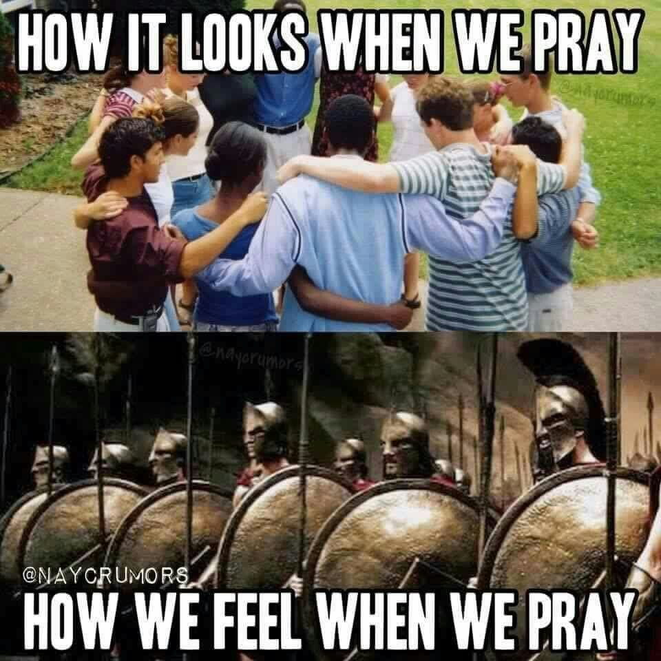

Always remember to pray for strength and to pray in groups for the work of outreach. God’s power gives strength. Remember the people of the Bible prayed for courage to share Jesus and for God’s support. Acts 4:23-31. Even the great evangelist, Paul regularly prayed for boldness. Ephesians 6:18-20. Let us always be prayer warriors for the cross and the cause of Christ.

