Ad Promotion of Bible themes and Bible sites

Thoughts: Consistency of ad promotion creates theme and site awareness saturation. The more people are exposed to a concept, site or company, the more likely they will tune into such with time.
See something 101 times, may not be interested, but when the right circumstances arrive, the right conditions, for the presented concept/theme, site/company, etc, they will cross through such doors.
The more personal the ad, the better.

How to create Facebook ads.
In using Facebook ad campaign, (How to create campaign? https://www.facebook.com/business/help/613846972027099).
I have found it is easy to set up.
- I first create a FB page, related to a Bible theme or Bible company/site.
(How to create Facebook page? https://blog.hootsuite.com/steps-to-create-a-facebook-business-page/).

- I then post on the Facebook page, something I’d like to share as an Ad.

- After posting on my FB page, there is a button below the post, called “boost post.”

- I click on that button. I’m given options to create the ad. It’s pretty easy and not too expensive.

Example: for 20 dollars, which is what I tend to use. I can reach a few hundred to a few thousand. If the amount of people reached is low, it can be according to my choices. Depending on how I gear the ad, if I want to focus on FC students, in the FL, Temple Terrace area, of the US, I can gear the ad to that location and to their age group and religious affliction. Even in this, I still get non-Christians, but it does help to specify the ad to what is desired in audience and location. If I gear an ad to a global or national level with a more general demographic of age and religion, etc. I will reach more people.

- Ad’s are great for promoting the true church, (or ones local church). The Mormons run ads on FB do promote their faith. Their ads take people to their church site, https://www.mormon.org/site/worship?fbclid=IwAR1KUxkhE2Sg-72I80ff4iPxl2_qhWsxVjNpFMeEUHNpGEAJGClGskEjjr8

- Facebook Ad’s are great for sharing Bible study sites and salvation themes.
- I WILL Post pictures of the stat’s and interactions of the ad’s I’ve posted. A picture is worth, as they say, 1,000 words.

The first picture below (shows some of) the ads I have run. The picture has the details on how much was spent and how many people were reached with the Facebook ads. It also details the FB email messaging conversations, I got from the ads that were run. After looking at the Facebook ad list in this picture. You can see each ad in more detail, (in the same order as the FB ad list)

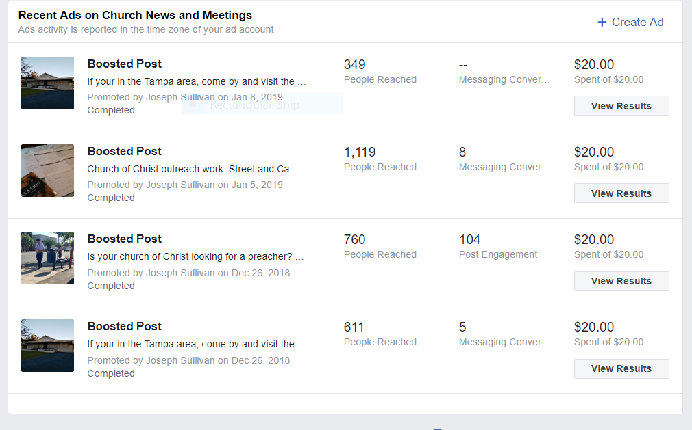

The first ad, is promoting the church I attend in Tampa, FL. I geared the ad to a specific age group, (college age). And to a specific location, Temple Terrace, FL, (where Florida College is at. FC is a Christian college). I also geared the ad to people in the “church of Christ.” You can see due to the specific limitations I placed in the ad to focus on a specific group…I had less reach and no Facebook email “messaging conversations.”

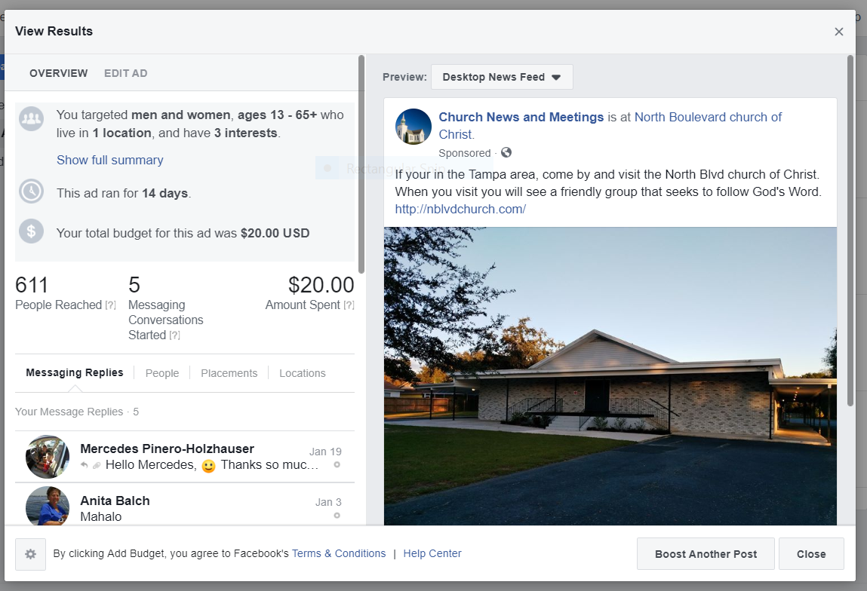
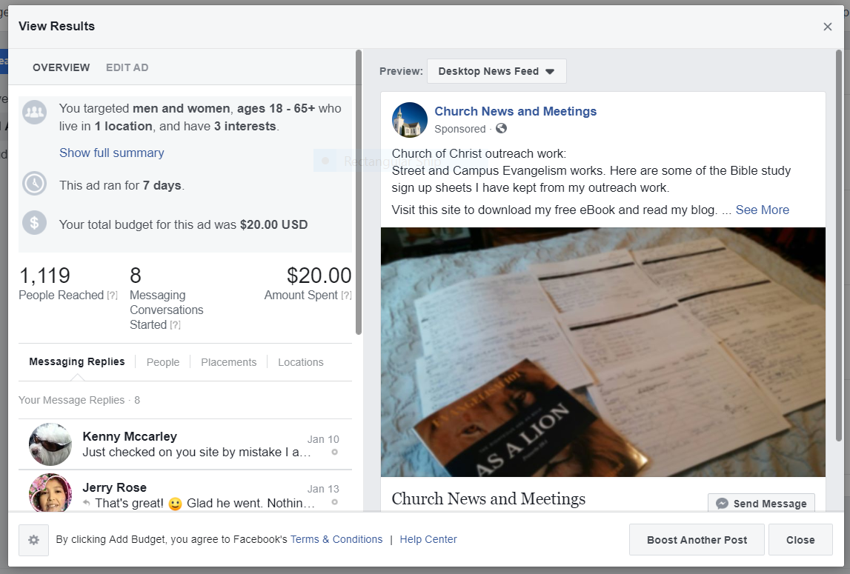
The second ad was for the US states of America. It was geared to people in the “church of Christ.” And had no limited age bracket. It did better due to having less limitations.

The third ad was a job placement ad for the FL area, in around an hour radius around Tampa. I had a larger radius and did not limit the ad to a specific age group. It was a very personal ad, personal statements, about a person or group, concerning, jobs, death, salvation, overcoming, etc, has a stronger appeal, then general theme statements.

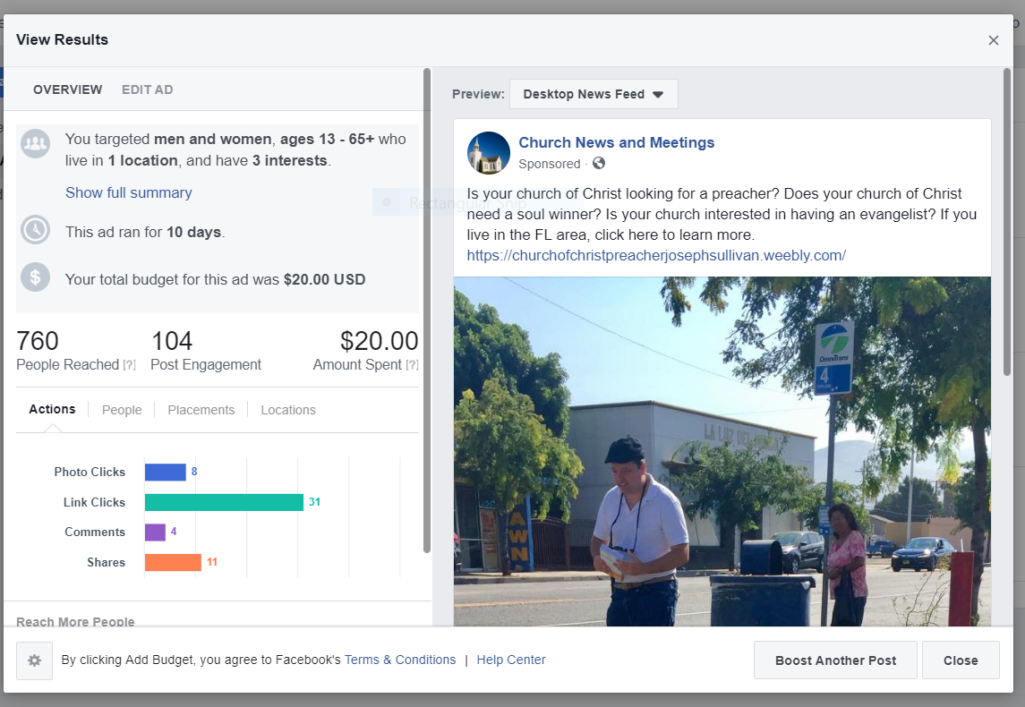

Google Adwords

- Let me just say, Google Adwords can reach people. But it is much more expensive, much harder to use and the ad placement is not always easy to see initially. You have to scroll down the search engine pages, where you typed in a search keyword to find the ad. Example: if you type church of Christ evangelism, you may see your site at the bottom of the first page, or at the bottom of the second. I use Google Adwords, but less frequently due to cost. In the end, it is worth it. See my link here, under “Cyber Evangelism,” for why such tools should be used.” https://www.churchofchristevangelism.com/methods.html

- How to do Google Adwords – video https://www.youtube.com/watch?v=zdiXrKXK5Xw
- Website tutorial - https://support.google.com/google-ads/answer/6146252?hl=en

- I use Google Adwords to promote the true church. I use words like “church of Christ” and “looking for a church.” If you read the link I shared on “Cyber Evangelism,” you know why this is important. I use the “keyword “church of Christ” because a lot of negative propagate is in this keyword. Denominationalism is deluding who we are online. False teachers are negatively branding us, using the keyword “church of Christ” in their website and Google adword placements.

- I also try to promote evangelism teaching aids in the church, with the keyword, “church of Christ evangelism.” For obvious reasons, this theme and methodology should be promoted.

Facebook ads and Google Adwords… allows a person to place their website in the ad for people to click on. So, if you have a church website, salvation website, a Bible resource website, etc. It’s a great way to drive up traffic. :D

