Blog: Virtual church of Christ Evangelism

Effective methods of online evangelism work
When I say virtual evangelism, I'm referring to effective online outreach methods. This church of Christ material below will detail successful venues that work. The below article on evangelism will share...

- Some of the best ways to reach people online.
- Online Bible courses and accumulating contacts and Bible studies (online and offline in your area).
- Online "street evangelism" idea and methods of implementation. ​

Powerful ways of generating contacts and studies!!

1. ​​Some of the best ways to reach people online

​Advertising online...

Facebook ideas that work.
I'd like to encourage my FB Christian workers online and offline to consider FB advertising. It is cheaper than Google advertising. I'll show pictures of both online ad groups, for you to get an idea of their reach and cost. And you get more impressions/online views. I am not rich. But if you are willing to cut a few things out of your budget you can have a 25 dollar ad each month. It will reach 1,000's. It will get clicks. Just make sure the ad is geared to website clicks and not FB comments. You don't want to pay for atheists, etc to troll your Christian ads...with comments. That's counterproductive. Also, if the ad is not geared to website clicks, but for comments, etc, you will get less website clicks.
As a heads up....you may still get some comments, even if the ad is geared for website visits. If someone does comment you can hide the comment, delete it and block the person from your ad. Below is a online Facebook platform I made to promote ads. https://www.facebook.com/Church-News-and-Meetings-1105119306174129/. If you don't have a FB platform, (Facebook fan page/Facebook group, this is important to set up before running ads).
For 25 dollars I tend to get around 20-200 clicks to my website. For 25 dollars to reach 1,000's and get even just 50 people visiting/clicking on my site is a win. That means they are interested and actively checking out what I am offering.
​Please note: If an ad does not perform well you can delete it and start again. Once you find an ad that gets good traction, you can reuse that ad again and again.
Facebook ads is effective in outreach, for through this venue you can invite people to visit your church site, or your salvation page, or promote a evangelism course, radio program, etc. Those who click on your website will be doing so out of interest, by making a (warm/inviting) ad on Facebook you can steer people to your content and to the goals your content represents. If you want to get people to visit your church, if you get enough clicks to your "church invite ad" you will get visits. The law of averages says it's about numbers and with ads, you'll reach 1,000's. Even with spending as I do 25 dollars, you'll reach 1,000's. For those reached, for the cost I spent, I again tend to get around 50-200 clicks. Interesting facts: when you run ads for 1 day, it is less successful on Facebook then if you do the (FB recommended) 4 days. I tend to get around 10 clicks for a good 10 dollar ad if I run it one day but can get up to 150-200 clicks to for the same amount if I run it for 4 days.
One of the best ways to run ads (on Facebook) on your group forum is through targeting members in your group. This method not only targets them but their friends on Facebook. Most saints tend to have COC friends, so this is a great way to draw even more people from the faith, if that is what your aiming to do. Give that a try to see if you like doing that format. Facebook ads gives a wide range of ways of reaching people. Experiment, see what works best for you. :)

Notice the difference between Google adwords and Facebook ads. Besides Google being a hard platform to use.

Google adwords
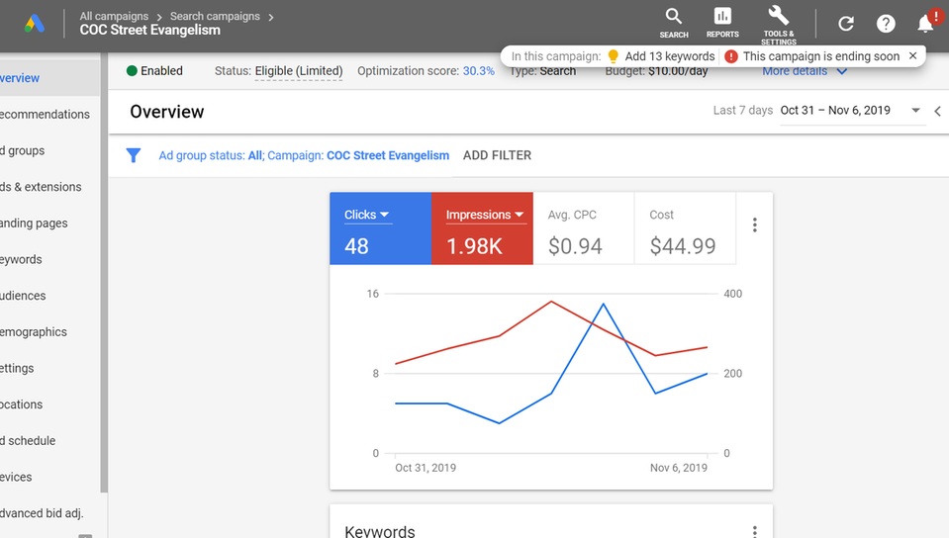

Facebook ads
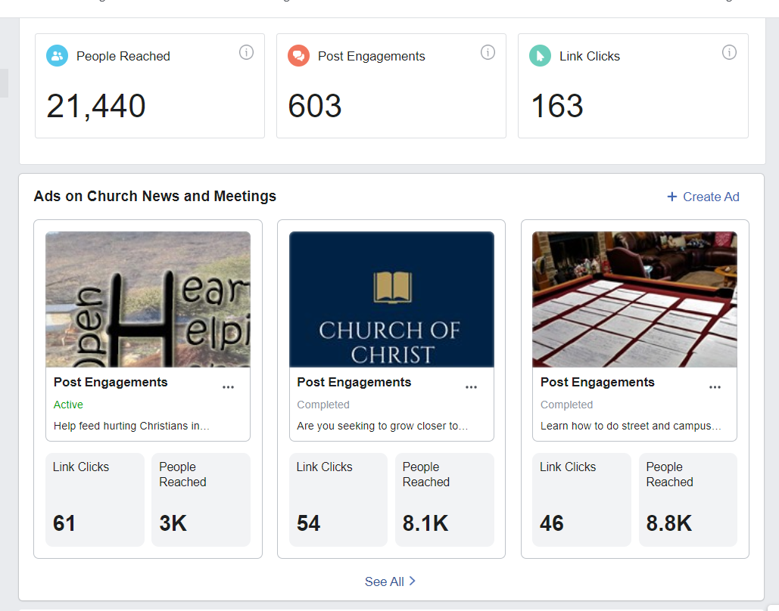
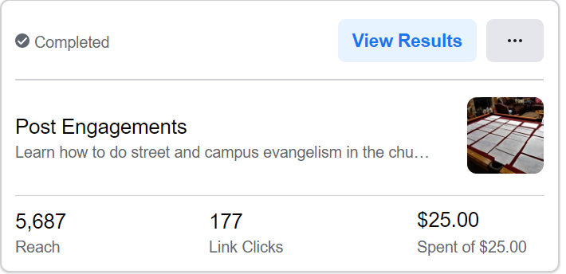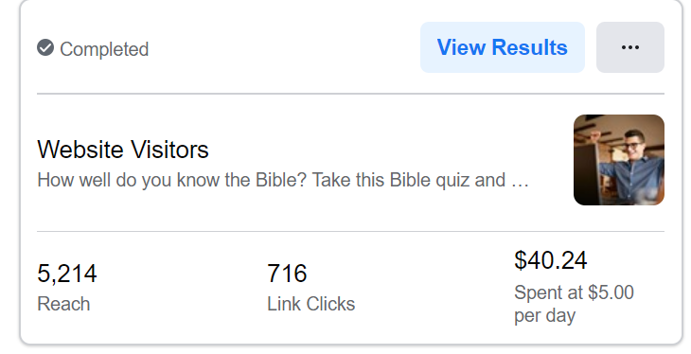

Facebook video promotion ad
​You get even more clicks using video ads then written ads.
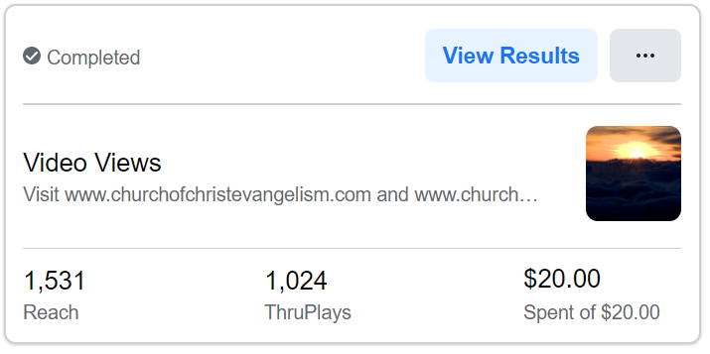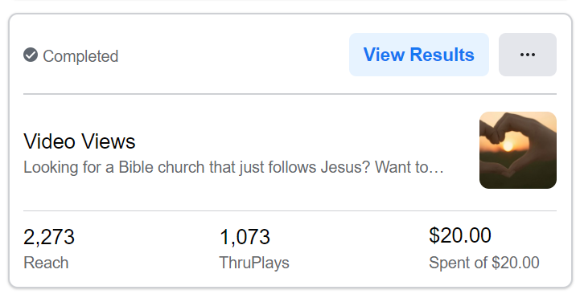

My tutorial on results and how to do a Facebook ad.

Note: if you want to promote your videos on Facebook and the goals behind that video, (sharing salvation, visiting church invite, generating interest in a religious website, inviting people in your area to a study, consider FB video ads. Such ads can reach a large group for low cost.

Facebook advertising data
Interesting stats I found on Facebook ads when running an ad on a religious theme. Picture 1 shows the ads do best in the Bible belts on America. Picture 2 shows most people are using cell phones to accessed ads. Most social media is being used through mobile cellular devices and less through PCs and Laptops. Picture 3 shows ads of a religious nature (seen this time and time again) are largely ignored by the youth. It's only when people are 50 and up that the spike/increase really begins to rise. This stat is about the same as the church attendance stat. Folks, we are losing the war with keeping our young people. The media, colleges, schools, secular campaigns to win our kids are winning. Another interesting stat on Picture 3, is that women, (see this time and time again) tend to click more on religious ads than men.
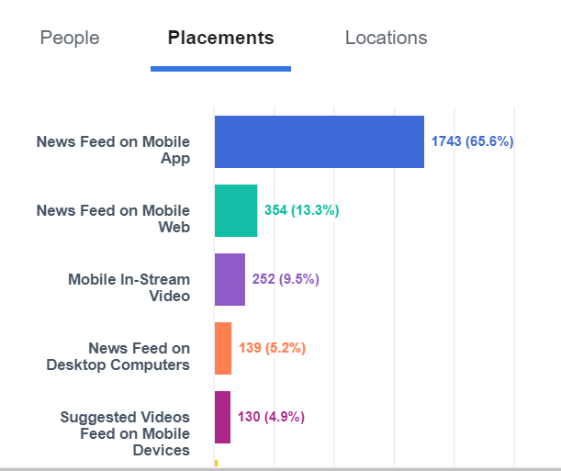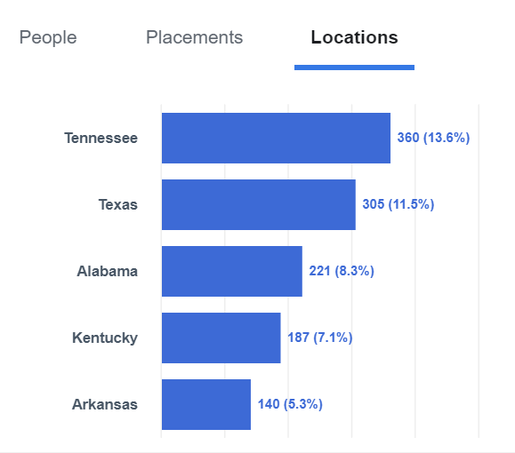

Bonus material: Also, I encourage you to explore YouTube video promotion, the ads are as cheap as Facebook's ads and this platform can serve the same purpose as Facebook in reaching people. See YouTube "How to" document, I got from a friend. This will detail how to set up a video ad and also, the rules of making a good video ad.
I spent around 70 dollars on a short video promotion ad on YouTube and got 4,000 clicks on my YouTube video and for my keywords "church of Christ evangelism" I got a high ranking on YouTube in the month of June of 2020. It may cost more or less to get clicks to your promo video. But the amount should be fairly cheap for the bang you will get out of your video.
​
Know YouTube uses Google adwords but through using YouTube as a platform instead of Google search engine, the cost is less expensive. I've heard instagram posts/ads is also another great avenue for generating contacts. Other search engine advertising platforms are costly and less effective than social media platforms.
I encourage you (when you get more comfortable with Facebook) to consider experimenting with other different social media ad platforms, to see if such networks like Twitter, Instagram, YouTube, Pinterest, are useful in your evangelism needs, (cost wise, ease of use, overall, all reach).
NOTE: Aaron Gallagher is an evangelist and preacher. He uses Instagram to get people to contact him to get Bible studies set up.
For other evangelists who use social media, see next post AND SEE the very bottom of the page...
Here's an example ad on YouTube. You can market ads on YouTube to your local area region.
Please know it does not need to be fancy. I've been doing videos for years. But the process can be simple, see my file here. But even simple videos can reach people and do alot of good.
Here's an example ad on YouTube. You can market ads on YouTube to your local area region.

Note: I wanted to highlight the benefits of social media advertising before I went into these other areas. I've spent 1,000's of dollars on SEO website promotion work and other venues to try to rank high on search engines. Yet still I am not listed where I want to be.
​You may have an amazing church site, or Bible resource site, or an evangelism outreach site. Yet if it's not being seen, it's not going to get traction. Even when it is in SEO, you may notice few visits. I was at one point ranked number 1 on Google for the search term, "church of Christ evangelism" yet I still only got about 30 something clicks to my site.

Online evangelism ads on social media can get you hundreds. And for cheaper cost then SEO work and ranking tools. :) Facebook and YouTube can better help you reach people for God's glory and for the goals of His kingdom.

2. Online Bible courses and accumulating contacts and Bible studies (online and offline in your area).

I first want to give credit to an exceptional evangelist, this man in a online Zoom meeting with other COC preachers and evangelists, shared his successful strategies. The concepts that were shown blew my mind. I implemented what was taught and got results..
​Let me outline what was shown and what I did to implement the advice given...but first let me introduce and credit the person who helped me. Please note, I don't know all the preachers beliefs in matters of their ideology. I share ideas from excellent evangelists, like Royce Bell, Ricky Shanks, Timothy Sparks, Etc. But I don't sit down with a questioner to make sure they are right in all matters of doctrine. Simply note: When I share a COC preacher or evangelist, I am not endorsing everything they believe. I am just sharing helpful resources that can help saints get results.
_________________________________________________________________
​Evangelist: Clint De France taught me and others his methods. Brother Clint says, he gets about 20 Bible studies a week by the process he does in evangelism work. He's grown his church doing this. Clint has given success stories as well. He detailed how a relative did this work and generated alot of Bible studies. I tried Clint's technique and got 100 Bible study signatures in 3 weeks.
If you want to learn more about Clint De France see his online contact info and resources.
- His congregational website
- Facebook page
- YouTube page​

Note: please read the first article on social media evangelism before reading the following. The foremost mentioned content will help give you perspective on what is about to be shared.

Below are the steps Clint showed me:
Step One:
​
​Clint makes a Facebook ad to invite people to visit his website to sign up for a Bible study course. See his ad and also another COC congregation example ad.

Clint's Facebook Ad
​See website sign up link
See the Facebook page where the ad is placed
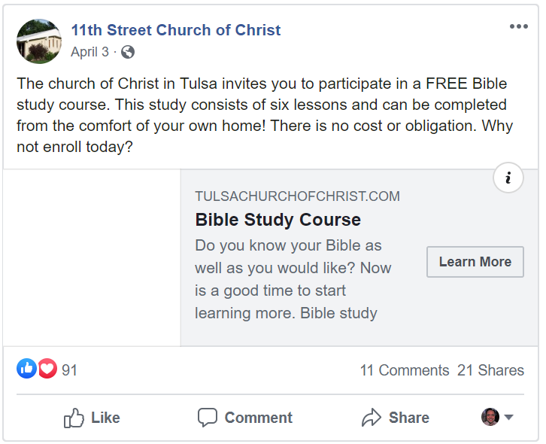

You can also use your churches Facebook page to promote singing up for Bible studies with "Facebook events" on the church FB page.
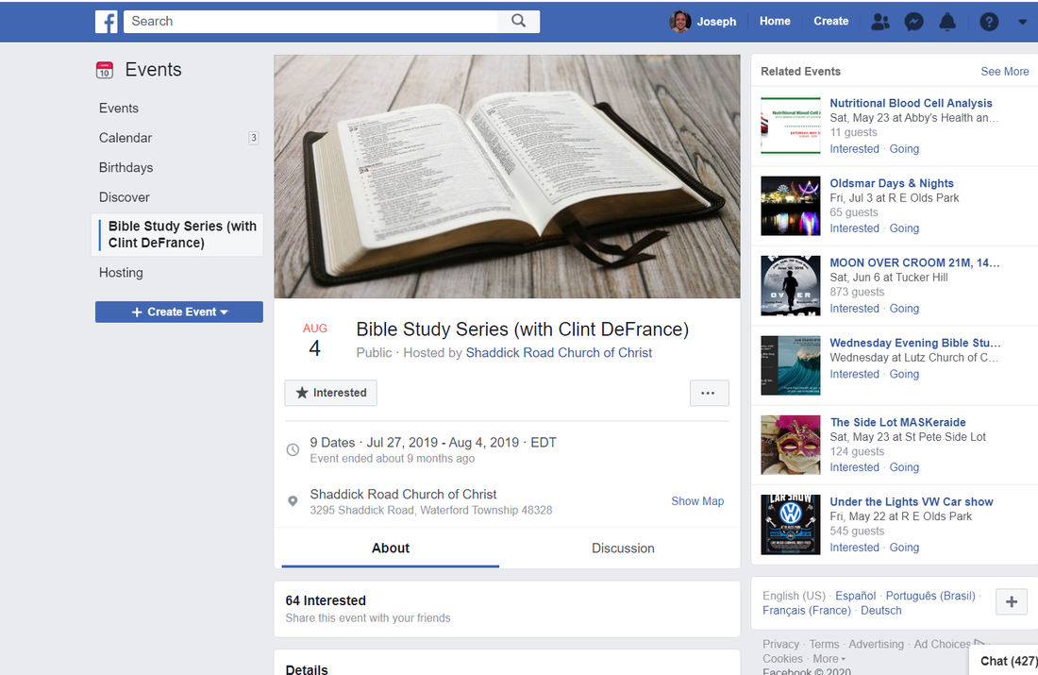

Another Example Facebook Ad from a different COC congregational group.
​Click on links to learn more about this other church assembly.
Also to get a better view of the Facebook ad. See website sign up link. See the Facebook page where the ad is placed
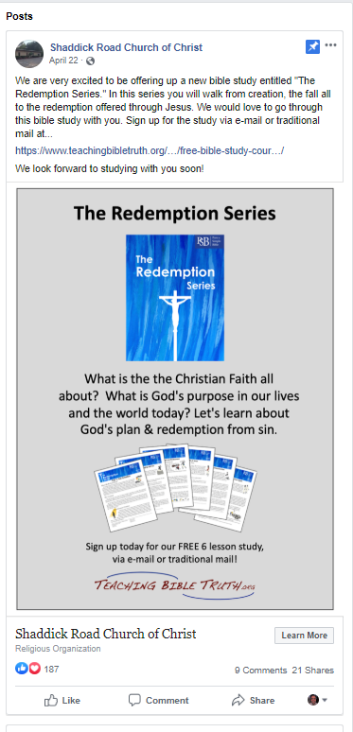

Step Two:
​
​Clint of course has a website where people can sign up for a Bible study course. He uses Weebly, (as do I). It's free and anyone who knows how to drag and drop preferred items on a page, can do it. Which is anyone. No HTML or code knowledge required. This website and my other sites are Weebly.

Step Three:
​
​The third step is very smart, Clint uses a online Bible study course platform. He uses Google Forms. It's easy to use, create courses with it's tools and is free. Brother Clint uses Facebook ads to target those in local area.
I encourage you to take his course on the website I showed you to get a better understanding of its content and it's qualities.

Clint first asks people on the Bible course to give their email address. This is needed to reach back to them to share the online students score and having an email helps further follow through. In evangelism it is important for people to give an investment, when people give their email and their name, it helps with corresponded, but it also helps build more of an emotional investment in the content the online Bible student has signed up for. Investments equal better follow through with those who invest. Also, having people share personal questions, is an investment.

Picture clips from the online Bible course

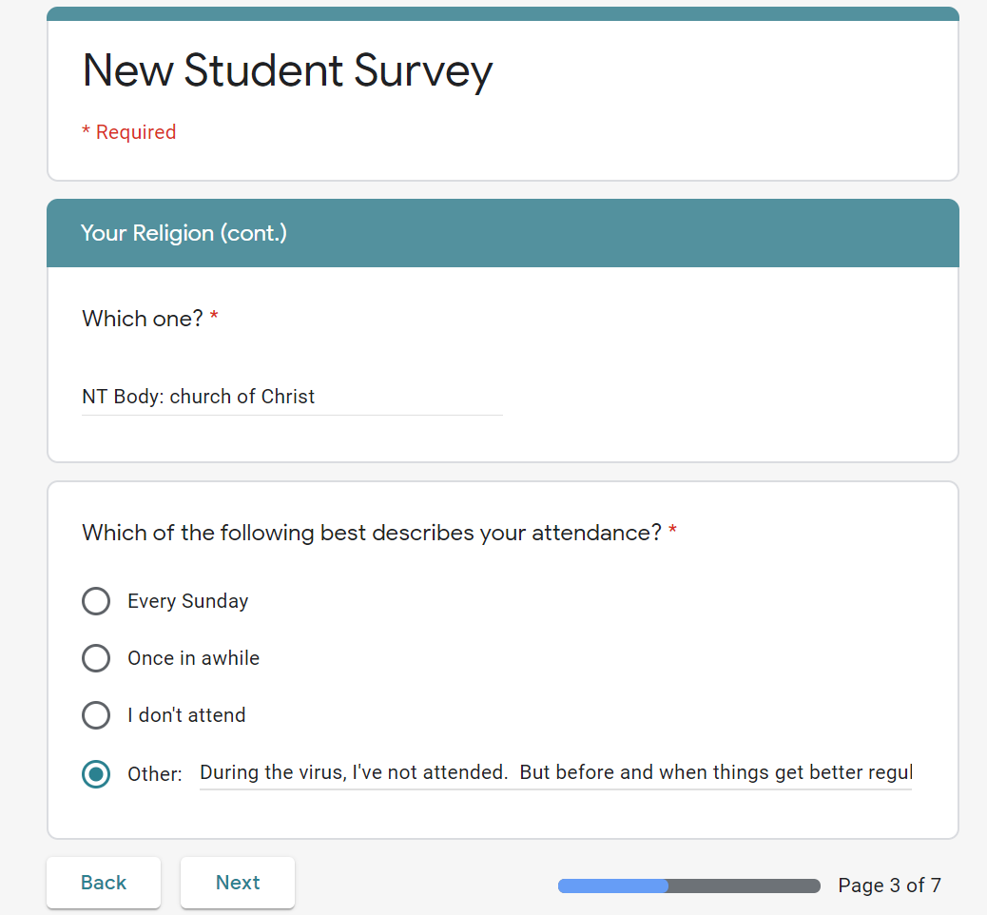
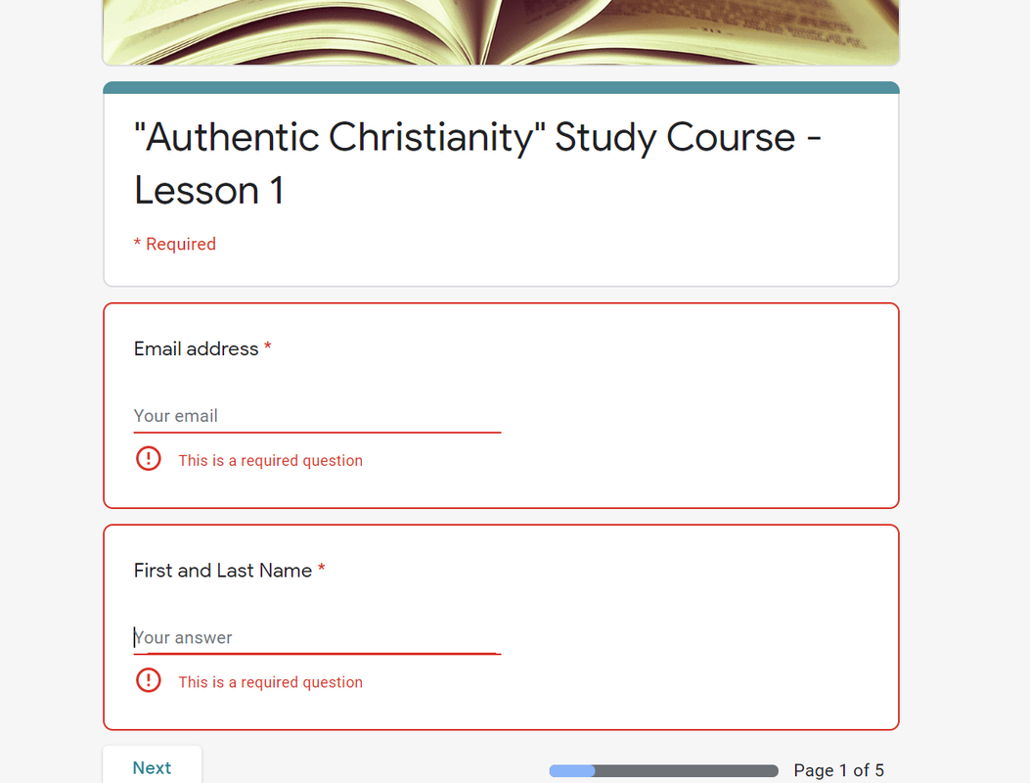

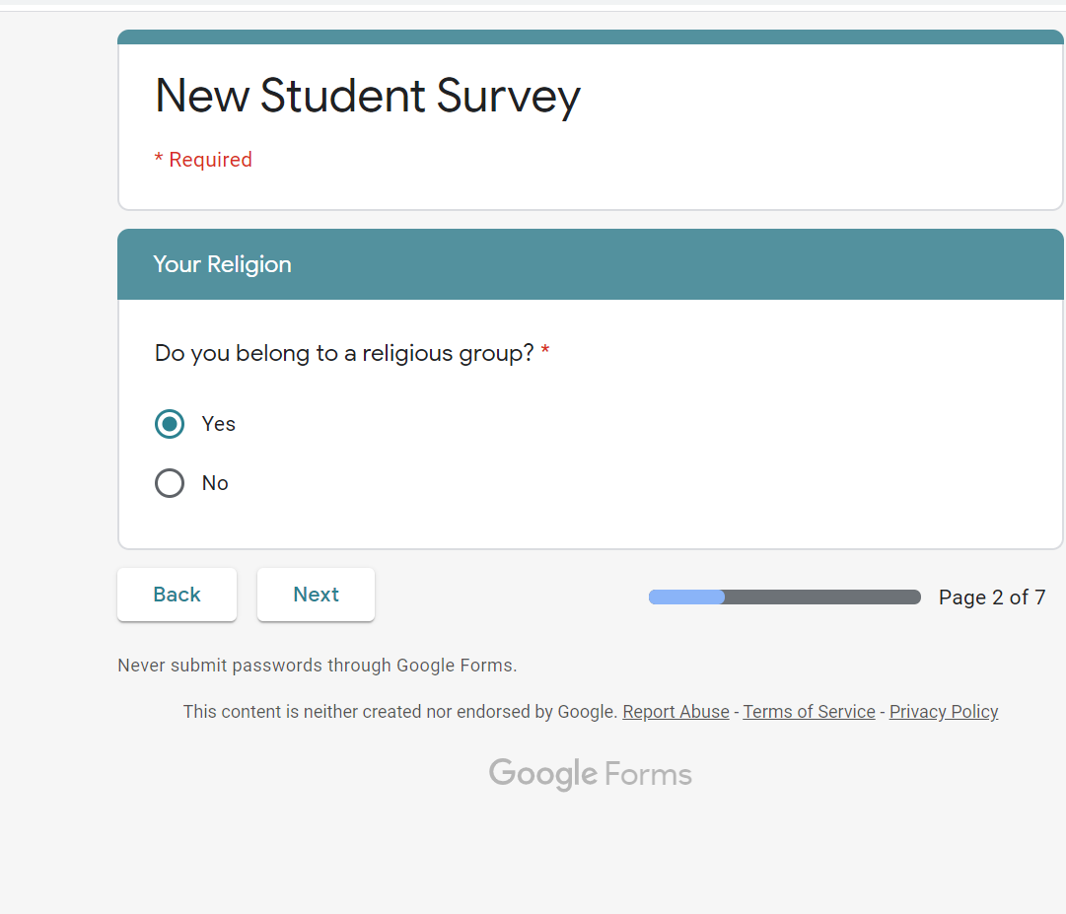

Also, it's good to ask if they were baptized and for what reason. To show later, if someone gets confused when hearing about baptism, for those who were baptized for the wrong reasons...

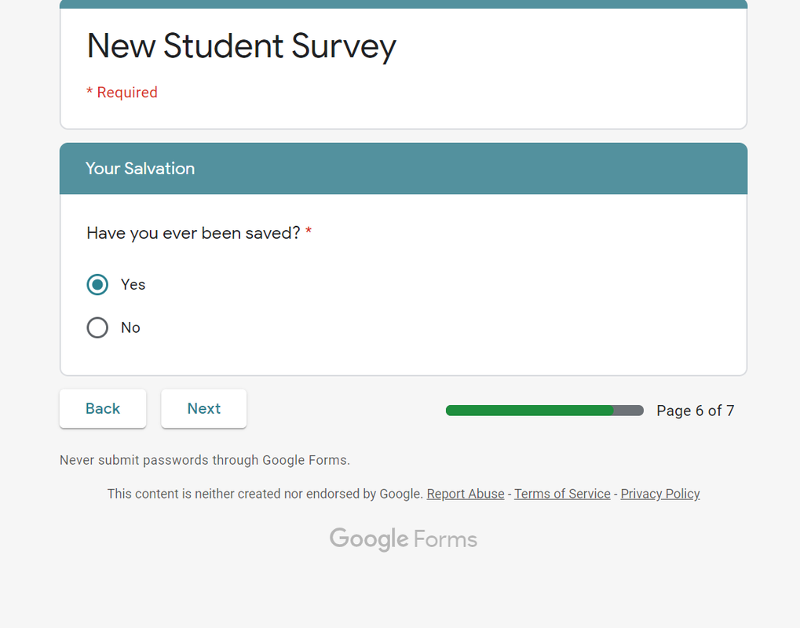
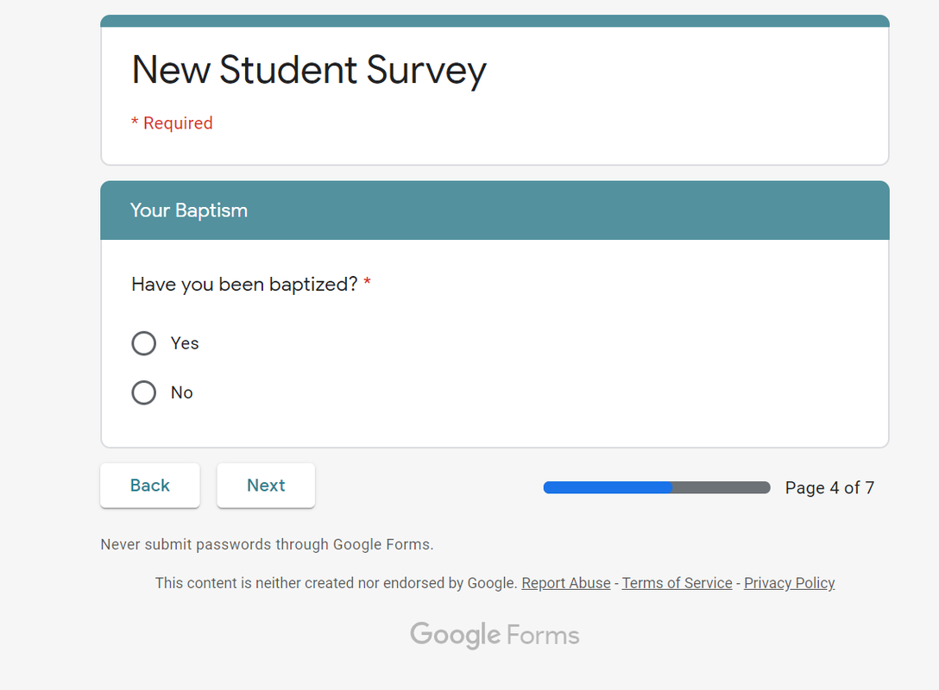
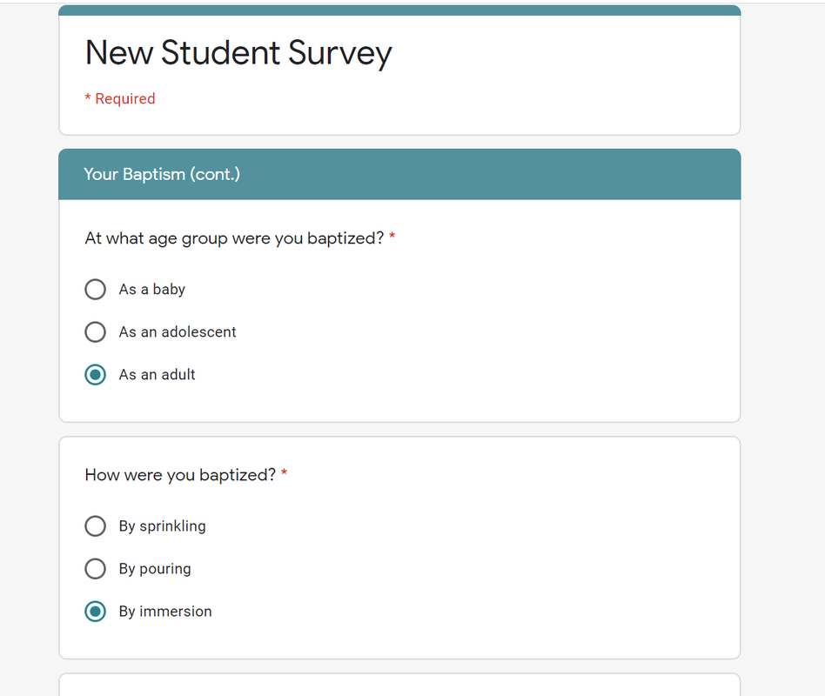

Step Four:
​
​Clint finds a good lesson source to make a online Bible study course. The saints help Clint with this work. They email those who take the online Bible study courses, the following lesson, after the previous is completed, with a professional/warm message.

There are 6 lessons in all. The courses are short and don't take too long to do.
Once the online Bible courses are done, the Bible student is contacted and invited to have meet for a personal study, to go over/review the content they did.

If they did Bible courses on the true church and salvation, then the review process can be a time to answer questions as well as reinforce the content in the shared study. Once the content has been reviewed, the question can be asked, if they would like to be saved.
The great thing about creating online courses for virtual study as well as a visit for a literal study is investment. They have invested their time, energy, social information, and their interest in answering the Bible questions. Investment is powerful for helping to generate follow through.
Again, Clint runs Facebook ads in his local area for the purpose of meeting up with the student to have Bible study's.
​Through this above mentioned formula, Brother Clint has had great success in reaching people.

What I do...in following
​Brother Clint's exceptional advice.
(Besides aspects mentioned above).
A. Instead of using Google Forms, I use FlexQuiz. There are many formats online for creating quizzes. But I found this to (for me) be the best. The platform is free, unless one wants to have their analyst tool. It shows how many signed up, their contact info, who followed through, etc.
B. Also the email responses are automated. When people finish, they are emailed (a prewritten message by me) with the results of the quizzes. The email has a PDF report on the answered they got right and if they passed a certificate of completion.
C. Like Google Forms, the Bible student can see their progress and how many pages they have left to do. I personal make my lessons around 30 minutes.
D. I encourage you to try out my Bible course as well to get ideas and to get a feel for it. I used Wix to create my online Bible course page. It is more costly then Weebly but has better drag and drop tools. See website here.
E. Once they finish the courses, they are shown a "reward page," that is hidden from the regular website viewer. See page here.

The purpose of this page is to reward the student not just with the progress of doing the online work or the certificate of completing that Bible work, but to give the Bible student online resources as a extra treat. If you click on the "reward page" you will see those students who finished the course, are given a personal Bible study invite for those who live in my area, (Tampa, FL. US).
I spent around 40 dollars in 2 weeks and got 700 clicks to my sign up page and got 100 signatures. This process works. Here are pictures of the ad stats and the ad post.
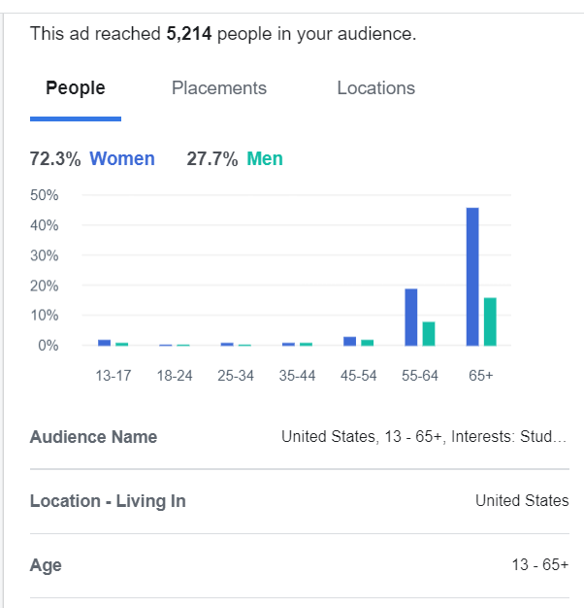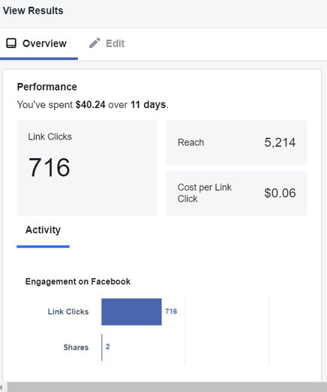
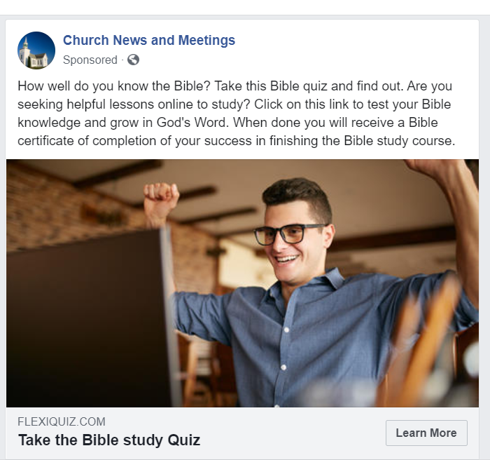

Also read my "Online street evangelism" article to fill in other blanks on how I interact with contacts. These two online venues in the above article and the article below... parallel each other in my evangelism work.

​
3. Online "street evangelism" idea and methods of implementation.

I'm fairly excited about this concept. I have been trained in street evangelism. If you peruse this website and its sister site, mentioned on my intro page, you will notice I detail alot of content referencing street evangelism. Why do I do this? Because it works.
It is an effective way of generating contacts and setting up Bible studies. Let me give you an example: when I work on a slow street area or at such places like a college campus, flea market, etc.
I may get 3 signatures for a Bible study in around a 3-5 hr. span. When I work in a moderate foot traffic area, I may get 5-10 in a 3-5 hour span. When I work in a high traffic area, I may get 10 signatures in a 2-3 hour span. Sometimes in 1 hour if it is really crowded.
What do I do to get Bible study signatures is simple, I give a invite like this, "would you like to sign up for a Bible study?" Some people talk to me about this and ask questions, some immediately sign up, some walk past and ignore the invitation.
Why am I talking about this here? What does this have to do with online evangelism? Well, if a person invites people and gets signatures in these venues, why can't he or she do the same online?
A personal invite in social media, through an ad can reach "cyber foot traffic." But instead of 100's for a few hours, a person can run "invite ad's" and after a few days, reach 1,000's. The law of averages says the more people you reach the likely it is you will get a desired response. I have found this to be true in door knocking, street evangelism, etc. As well as in social media ads.
With Facebook and even with YouTube, you can run ads targeting people in you local area. You can make a warm invite and reach 1,000's in your desired region. All you have to do is spent the time to make a nice web page for people to click on to visit your site to sign up.
I target people within an hour from my local church. If they live 2-3 hours away, the drive is hard, and it will be hard to maintain a connection from a further distance. They will also be too far from the local church building.
Facebook enables you to put down a marker where you want to measure the outgoing miles from. I pick a well-known location near the church building to place my marker, if the church location does not show up.

​

I am going to show you my online ad on Facebook.
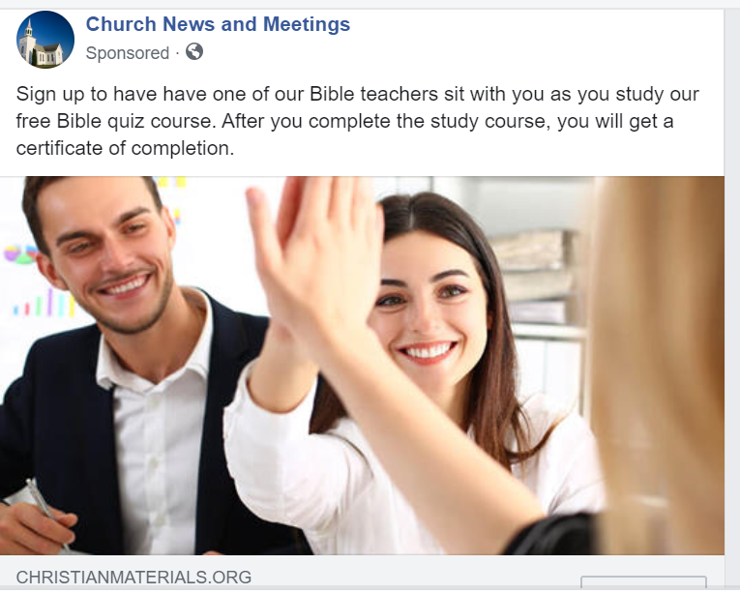

​Check out the website link connected to the ad.
www.christianmaterials.org/sign-up-for-bible-study-course.html

Notice the format and patterns I used on the website.
- I used a free website platform, Weebly. It is easy to make websites with Weebly, even if a person is not HTML, etc. savvy. It's a drag and drop button/content plate-from.
- I used a logo and a group name to build trust and credibility.
- I attached the page invite to a larger site that is respectable to build trust. Have one page for a site, with no narrative about the group, by having other invested/credible content listed is not as effective as a site that has "trust building resources."
- I did not attach the site to a COC congregation. I want people to view this as a autonomous group helping them with doing Bible studies, not a "recruitment to join a church congregation." Please note, others do use their congregational website and they get results, this choice for you to decide and of course is optional.
- I answer some questions people may have to build trust. But I try to not be overly specific. I don't want to share for example pictures of the Bible teachers, they may be turned off, if they see someone they think is to old or to young, etc.
- I give the interested parties positive Bible based incentives. I have a certificate of completion mentioned, they will get after finishing the study course, (Johnnie Edwards Home Bible Study pamphlet lessons). I also mention the pros of doing this course, like learning about the Bible, sharpening one’s mind, growing closer to Jesus. The more reasons that are given that people find appealing the more likely they are to give this venue a try.
- I have pictures of happy/smiling people. This is a good marketing strategy. And evangelism is marketing.
- In my sign-up sheet I give people an option on where they want to meet. We can meet them at their house, apartment, nearby fast food restaurant, my nearby church. They may not be comfortable with meeting at their local residence, so this option, help us encourage people to sign up. I also ask them to give me the best days and times to meet up. I get back to them on a time that works for us both and the designated person who is helping me in the meet up.
- I let those who sign up know, there is going to be another person present, (1 male, 1 female). This is especially important for studying with women. In connection to their comfort level.
- I encourage them to have a friend or family member present if they wish. This again, helps with people, being comfortable. Not just women, but even, sometimes men. ​

______________________________________________________________________________

Don Bunting has success in doing ads to get Bible studies, visit this article to learn how.

For evangelism Branding and online media ideas please see this Document.

To access the copied content on this website in file form, please click here.

___________________________________________________________________________

This content is made by Joseph Sullivan.

His website and more resources ranging from training videos, lessons to books, etc.

Visit www.churchofchristevangelism.com to learn more.

____________________________________________________________________________

